

|  |
| --- |
| Key observations:   * Data Focus: *The report is centeredd around understanding the relationships between exports, imports, health indicators, and a range of economic factors at the country level. This suggests a broad analytical goal, potentially related to understanding global trade dynamics, the impact of health on economic performance, or identifying countries with specific development profiles.* |
| *Country Data* |
|  |

# 

# Visualizations:

# Scatter chart : The primary visualization is a scatter plot showing the relationship between "Sum of exports" and "Sum of imports," with data points colored by "health." This allows for the observationof potential correlations between trade flows and health indicators.

# Pie Chart: A smaller pie chart at the bottom left shows "Sum of chita mort" (likely child mortality or a similar metric) by country. This provides a quick overview of the distribution of this health indicator across different countries.

# 

Multi-Row Card: Several multi-row card visuals display key aggregated data, including sums of exports, imports, income, inflation, Gini coefficient (gapp), total fertility, and life expectancy. These provide high-level summaries of important metrics.

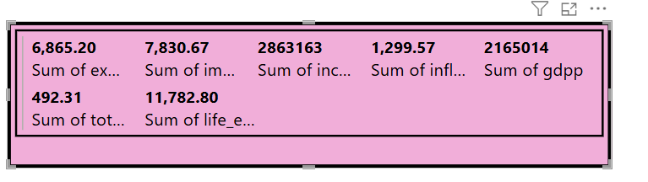

Filters:

* Country Filter: A prominent filter on the right side allows for the selection of specific countries.

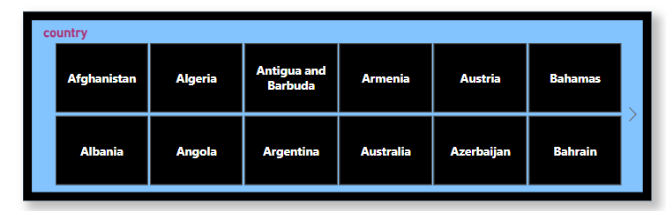

Conclusion:

*report provides a valuable starting point for understanding the complex interplay between trade, health, and economic development at the country level. The scatter plot of exports vs. imports, colored by health, allows for the exploration of potential correlations between trade patterns and health outcomes. The pie chart of child mortality serves as a stark reminder of the disparities that exist in child health across nations. The multi-row card visuals offer a convenient overview of key economic indicators, enabling comparisons and the identification of potential relationships with health and trade data.*